PROJECT 5
AI-Powered Resume Screening and Candidate Data Extraction
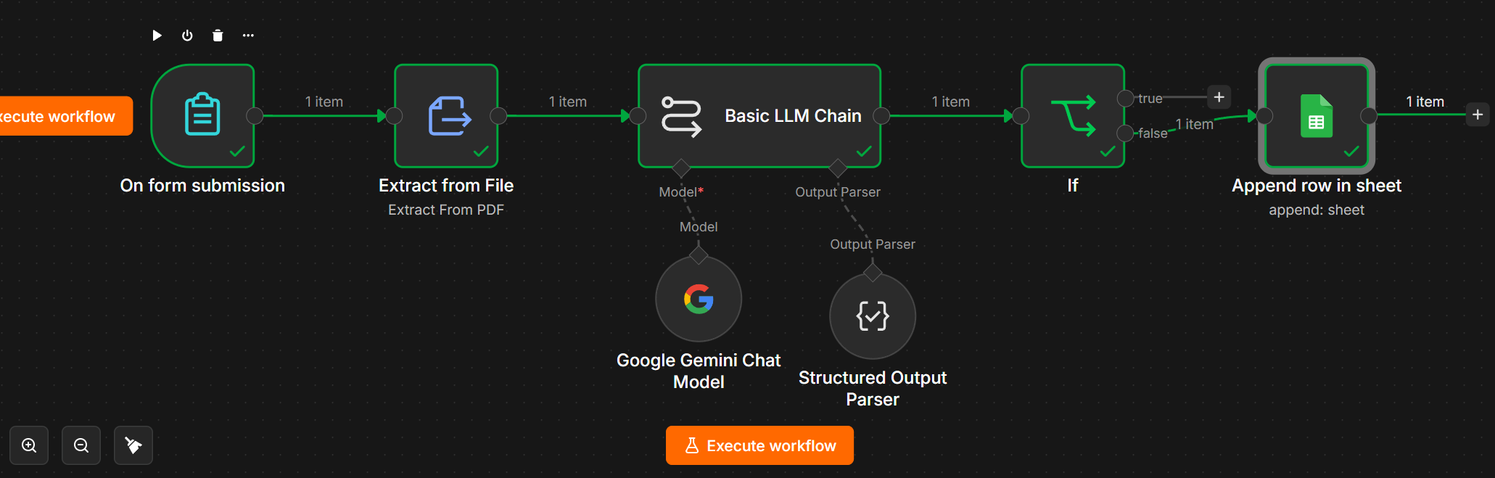
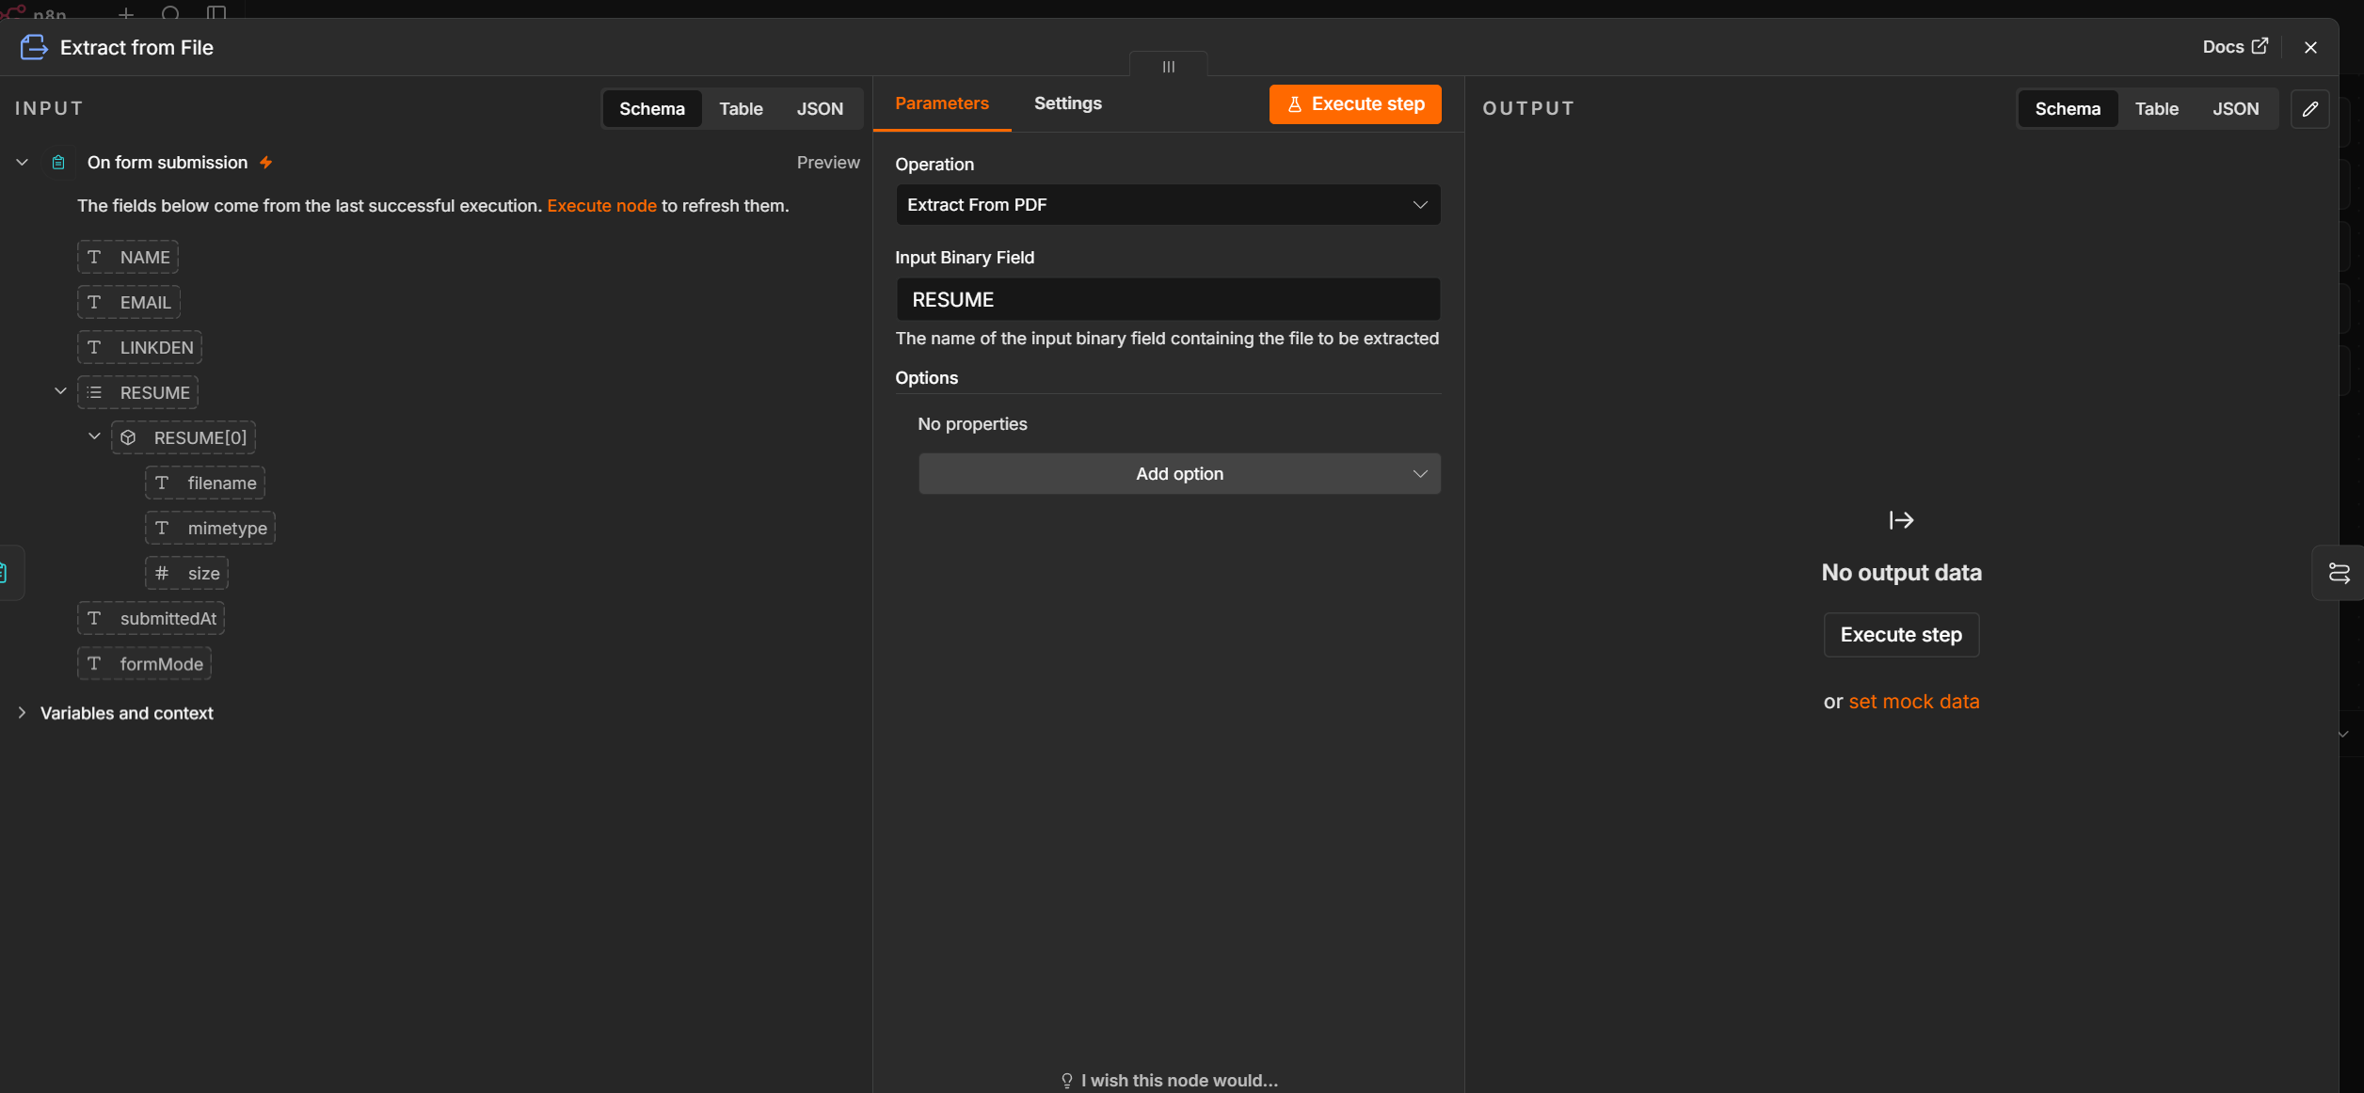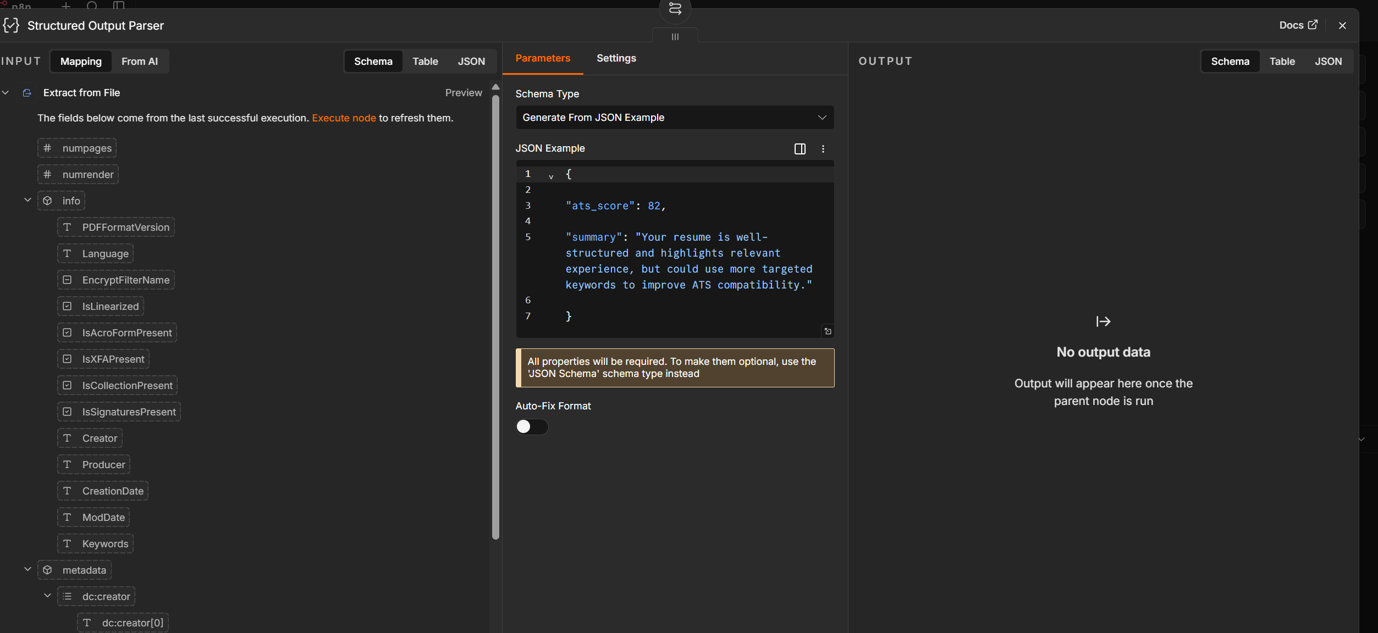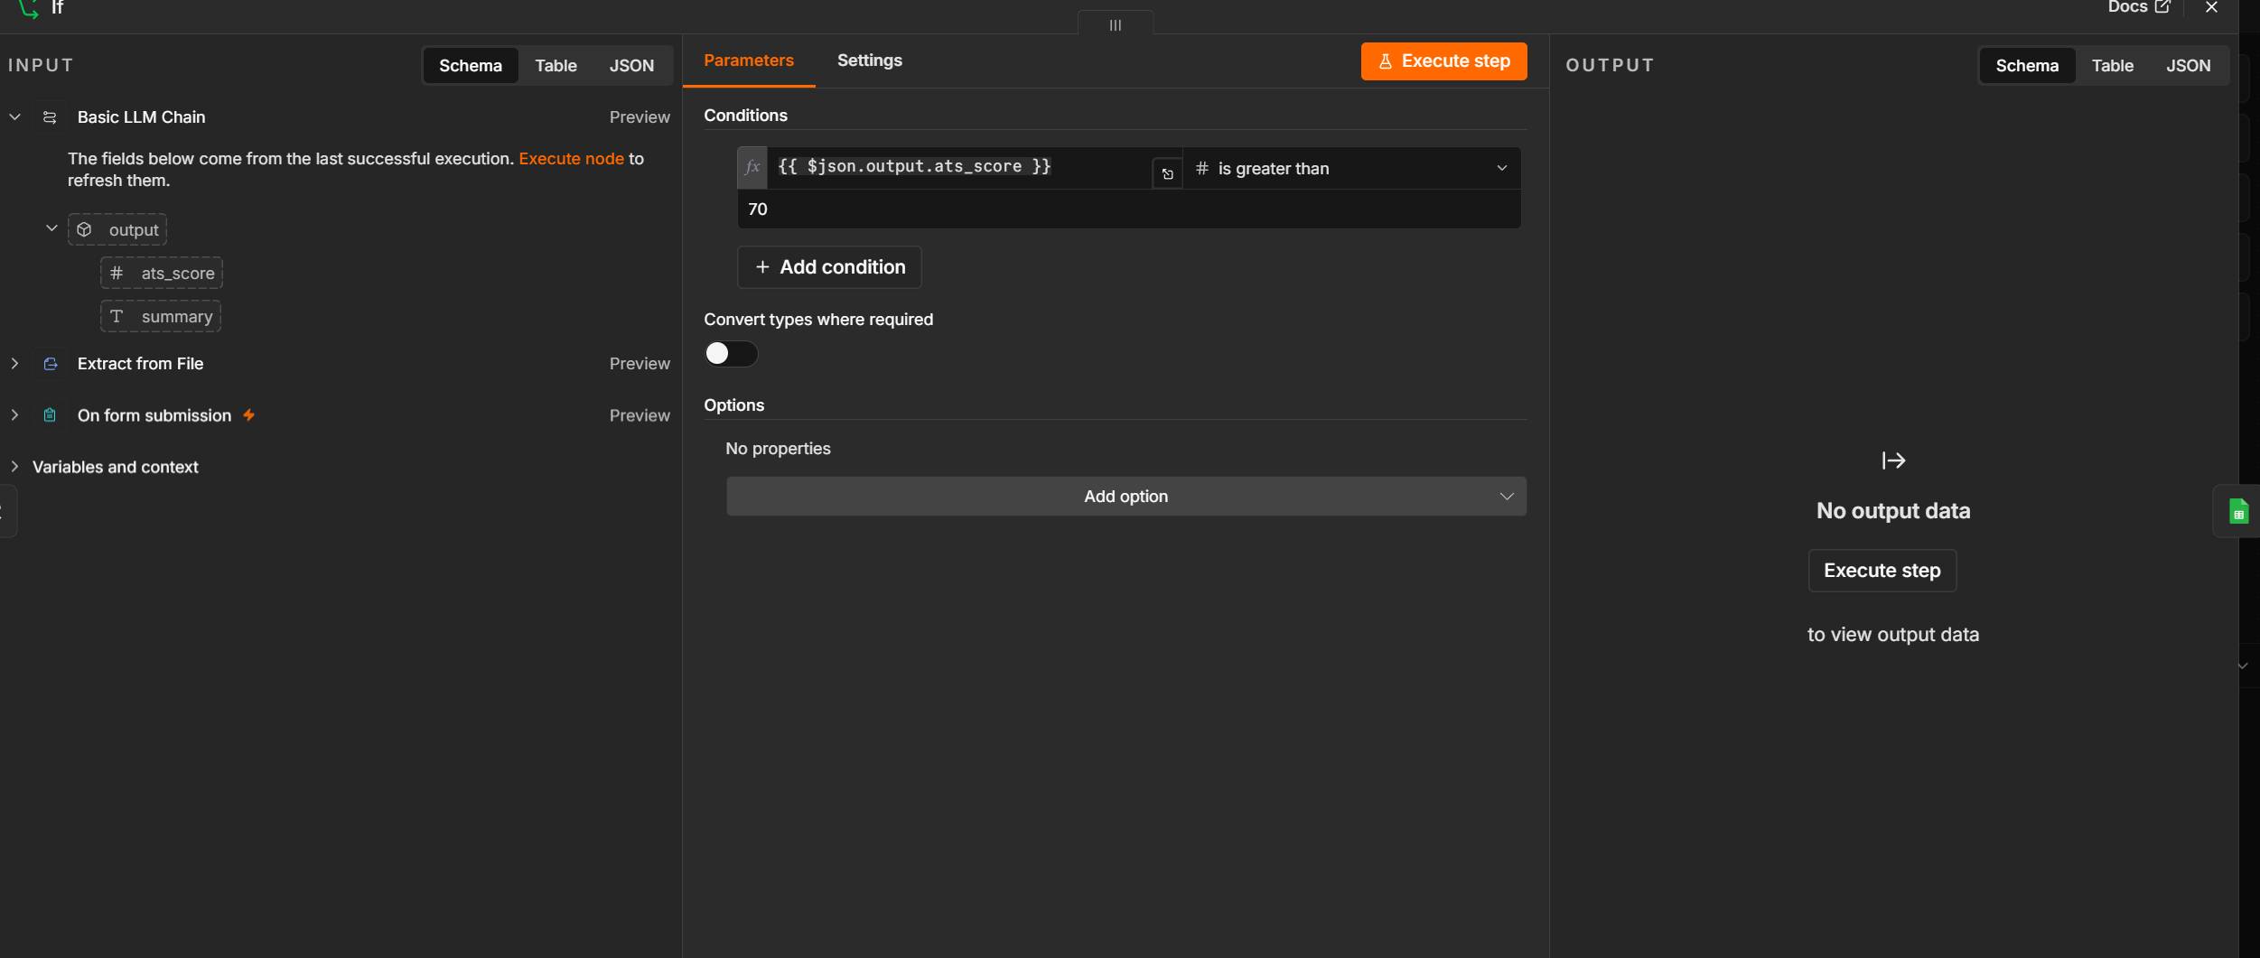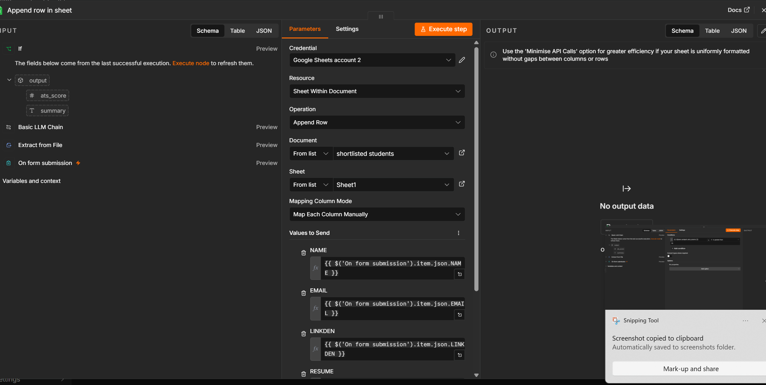
Project Information
Project Title: AI-Powered Resume Screening and Candidate Data Extraction
Platform: n8n
Purpose:
This workflow automates the process of receiving candidate resumes, extracting text from PDF files, analyzing the resume using Google Gemini AI, filtering candidates based on predefined criteria, and storing shortlisted candidate details in Google Sheets.

1. Overview
The workflow uses artificial intelligence to streamline the resume screening process. Candidates submit their resumes through a form. The workflow extracts the text from the uploaded PDF, analyzes it using the Google Gemini Large Language Model (LLM), checks whether the candidate meets the required qualifications, and stores eligible candidates in Google Sheets.
This eliminates manual resume screening and speeds up the recruitment process.

2. Workflow Architecture
Candidate Uploads Resume
│
▼
On Form Submission Trigger
│
▼
Extract Text from PDF
│
▼
Google Gemini AI
(Basic LLM Chain)
│
▼
Check Eligibility (If Node)
│
┌────┴────┐
│ │
Eligible Not Eligible
│
▼
Append Candidate Data
to Google Sheets

3. Workflow Components
Node 1: On Form Submission
Purpose
This node serves as the entry point of the workflow. It is triggered automatically whenever a candidate submits the application form along with their resume.
Input
The form typically collects:
- Candidate Name
- Email Address
- Phone Number
- Resume (PDF)
Output
The uploaded PDF file is passed to the next node.

Node 2: Extract from File
Purpose
This node extracts readable text from the uploaded PDF resume.
Operation
Extract From PDF
Processing
The node reads the uploaded resume and converts it into plain text.
Example Extracted Text:
John Doe

Education:
Bachelor of Technology
Computer Science

Skills:
Python
Java
SQL
Machine Learning

Experience:
Software Engineer - 2 Years
Output
The extracted resume text is forwarded to the AI model.

Node 3: Basic LLM Chain
Purpose
The Basic LLM Chain sends the extracted resume text to the Google Gemini Chat Model for intelligent analysis.
The AI is instructed to analyze:
- Candidate Name
- Skills
- Experience
- Education
- Contact Information
- Eligibility Status
The AI returns structured JSON.

Google Gemini Chat Model
Purpose
Google Gemini acts as the Large Language Model responsible for understanding the resume.
Example Prompt:
Analyze the following resume.

Extract:

- Name
- Email
- Phone
- Highest Education
- Skills
- Years of Experience

Determine whether the candidate is eligible for the Software Developer role.

Return JSON only.

Structured Output Parser
Purpose
The Structured Output Parser converts the AI response into clean JSON.
Example Output
{
"name": "John Doe",
"email": "john@gmail.com",
"phone": "9876543210",
"education": "B.Tech Computer Science",
"skills": [
"Python",
"SQL",
"Java"
],
"experience": 2,
"eligible": true
}
Using structured output ensures that downstream nodes receive consistent data.

Node 4: If Node
Purpose
The If node evaluates whether the candidate meets the required criteria.
Example Condition
Eligible == True
or
Experience >= 2 Years
or
Skills contains Python
Decision
If TRUE:
Candidate proceeds to Google Sheets.
If FALSE:
Workflow ends without storing the candidate.

Node 5: Google Sheets
Purpose
Stores shortlisted candidate information.
Operation
Append Row
Spreadsheet Columns
Candidate Name | Email | Phone | Education | Skills | Experience
John Doe | john@gmail.com | 9876543210 | B.Tech | Python, SQL | 2 Years
Every eligible candidate is automatically added as a new row.

4. Complete Workflow
Candidate submits application
│
▼
Trigger workflow
│
▼
Extract text from PDF
│
▼
Google Gemini analyzes resume
│
▼
Structured JSON generated
│
▼
Eligibility checked
│
┌─────┴─────┐
│ │
Eligible Rejected
│
▼
Store in Google Sheets

5. Input Data
Form Submission
Name:
John Doe

Email:
john@gmail.com

Phone:
9876543210

Resume:
resume.pdf

6. AI Output
{
"name": "John Doe",
"email": "john@gmail.com",
"phone": "9876543210",
"education": "B.Tech",
"skills": [
"Python",
"Java",
"SQL"
],
"experience": 2,
"eligible": true
}

7. Google Sheets Output
Name | Email | Phone | Education | Skills | Experience
John Doe | john@gmail.com | 9876543210 | B.Tech | Python, Java, SQL | 2 Years

8. Technologies Used
Technology | Purpose
n8n | Workflow Automation
Form Trigger | Receive Resume Submission
PDF Extractor | Extract Resume Text
Google Gemini Chat Model | AI Resume Analysis
Structured Output Parser | Convert AI Response to JSON
If Node | Eligibility Decision
Google Sheets API | Store Candidate Information

9. Advantages
- Fully automated resume screening.
- Eliminates manual data extraction from resumes.
- Uses AI for intelligent candidate analysis.
- Filters candidates based on predefined hiring criteria.
- Stores only eligible candidates.
- Reduces recruitment time.
- Improves consistency and accuracy in candidate evaluation.
- Easily scalable for handling large volumes of applications.

10. Possible Enhancements
- Send acceptance emails to shortlisted candidates.
- Send rejection emails with feedback.
- Calculate a candidate match score (0–100%).
- Integrate with ATS platforms (Greenhouse, Lever, Workday).
- Store resumes in Google Drive or AWS S3.
- Notify recruiters via Slack or Microsoft Teams.
- Generate interview schedules automatically.
- Create dashboards using Power BI or Looker Studio.

11. Conclusion
This AI-powered resume screening workflow automates the end-to-end candidate evaluation process. Starting from form submission, it extracts resume content, leverages Google Gemini AI to analyze and structure candidate information, applies eligibility rules, and records qualified candidates in Google Sheets. By reducing manual effort and improving consistency, the workflow provides a scalable and efficient solution for modern recruitment processes.

